You may now order for multiple people without creating separate orders. Here's the new process, step by step:

When you log in, you will be taken to a new page and asked to enter names.

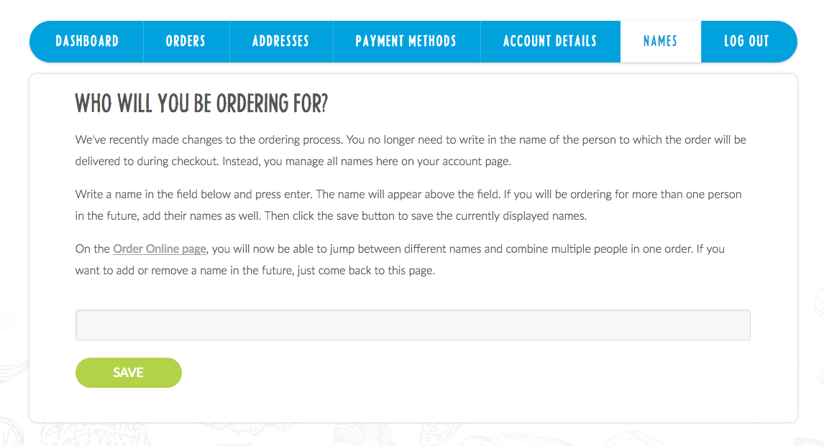

Enter the names of anyone who you will be ordering for and click enter after each. You will see their name above the input field. These names can be updated at any time on your account page.

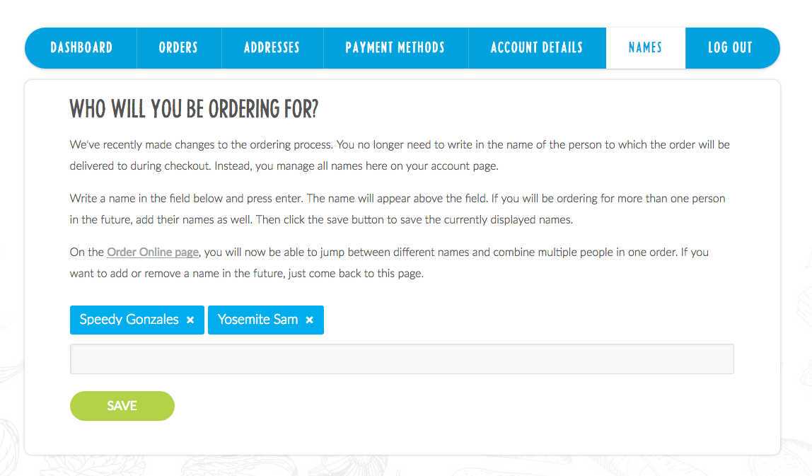

Click the save button. You should see a pop up telling you that the names have been updated.

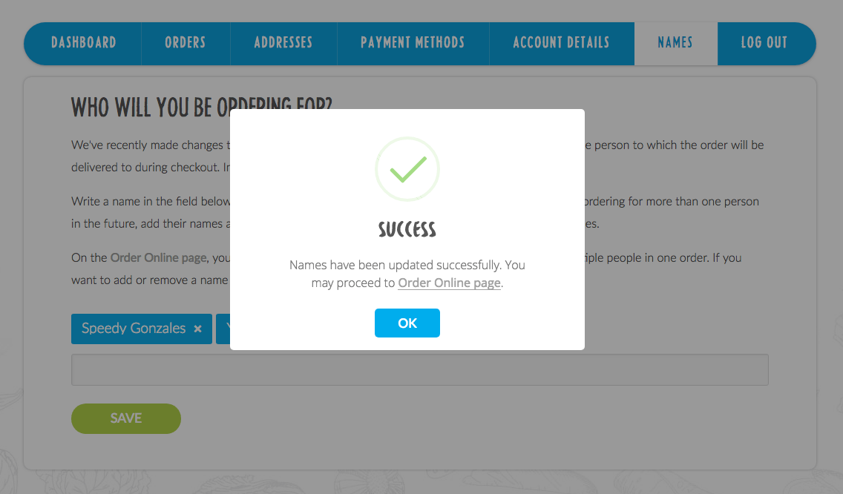

Now you may proceed to the 'Order Online' page. The names you entered will be displayed in a dropdown above the calendar. The displayed name is who you are currently ordering for.



If you entered multiple names and want to order for a different person, click the dropdown and change to their name.



When you go to the cart page, you will see that the names are attached to the items in your order. You no longer need to enter a name on the checkout page.

